A Qualifications Genealogy, or why it makes sense to use the resources of Family History Writing Specialists to help tell your story

My expertise in Life Writing comes, in part, from taking advanced university courses in the ways people represent the lives of others and themselves in stories, and how they find meaning through the telling. I hold a doctorate in what might easily be called Life Writing, since Literature is all about the lives and experiences of people, their archetypal journeys to Heaven or descent into Hell. I have read and studied most of the most important books/stories in the English language, with a specific focus on American Literature and two of our greatest storytellers, Melville and Faulkner.

Also, because I like to listen to storytellers, I did a lot of advanced coursework and projects in disciplines like Folklore, Oral Narrative, History, Cultural/Gender Studies, Women’s Studies, and Native American Studies with top scholars like Scott Momaday and Barbara Babcock. I learned Narrative theory and the aesthetics of storytelling. I started writing sophisticated and scholarly life studies beginning with the experiences of five generations of pioneer women in southern Utah.

I learned how to help others do Life Writing while teaching in the English departments and Honors Programs of several state universities and colleges, and at a large, private, Western, highly-selective, faith-based university. Altogether, I taught Life Writing strategies and skills to thousands of students, even though the catalog actually listed the courses as College English, Honors Writing, Writing papers about Literature, Business Writing, and others. The various modes of writing described in Classical rhetoric, such as narration, description, the personal narrative, cause and effect essay, and advanced expository writing are all built around personal experience and personal opinion.

I also started doing professional freelance writing and editing for business and industry clients but gradually found increased satisfaction in working with personal and family history clients. It goes without saying that along the way I acquired all kinds of arcane knowledge about both Content Editing for theme, organization, and development, and Copy Editing for style and mechanics, such as grammar, syntax, usage, spelling, and punctuation.

I learned further about the purposes and aesthetics of Life Writing by engaging directly with life and trying to figure out what it all means through writing. There are limits to what one can know by reading books, and as Cervantes said of Don Quixote, “from much reading and little sleep his brains dried up and he lost his wits.” At some point you have to immerse yourself in the destructive element (says Joseph Conrad in Heart of Darkness) and see what happens. Like Shanghai McCoy says in True Grit, I’ve “. . . been around the Horn, sailed the seven seas, seen everything, done everything, that's how I know people are rotten. I've seen 'em all.” You gain a lot of empathy for people if you have looked up into the sky and said, “I’ve played the cards I’ve been dealt. I done the best I could, and that’s all there is and there ain’t no more.”

I have learned that Storytelling and Life Writing are indispensable ways of exploring the spiritual dimension of life and knowing about the divine. Jim Faulkner (Philosophy professor at BYU) once said that we don’t have a theology or theologians. What we have is a bunch of stories about the presence of the divine in people’s lives. The scriptures are mostly stories, Life Writing, about two large and complex families doing the best they can with what they have got. The stories are not self-interpreting artifacts or texts that “say what they mean and mean what they say.” There is no such thing, and there is always an interpretive process at work as they (and we) try to figure out what is going on, how to act in a given situation, and how to be. We are invited to participate in that interpretive act.

A testimony is not (or should not be) the assertion of abstract theological and epistemological generalities about “knowing” something, but rather a story about how you came to know the truth of a doctrine, teaching, principle, or precept, and we see storytelling events constantly in scripture, such as those men on the road to Emmaus engaged in a peaceful walk and conversation with a stranger about rumors, stories, they had heard about Jesus, and coming to an epiphany and realization of who that stranger was by the “spontaneous overflow of powerful emotion recollected” later.

When I worked in the First-year mentoring program at BYU helping all 5,000 new students adjust to university life, we developed a model for written Reflections that was not only modeled after Dewey’s thought on the matter but also on the notion of “pondering” and “ponderizing” which enabled students to tell their stories and productively analyze their experiences to help them learn, grow, and change.

Ultimately, through graduate study of the theory and aesthetics of Life Writing, reading and analyzing a substantial amount of Life Writing, doing ethnographic research and scholarly writing, and teaching others how to use Life Writing in productive ways, I have developed a unique set of Life Writing skills, particularly as an editor, writer, and consultant, that I share with others.
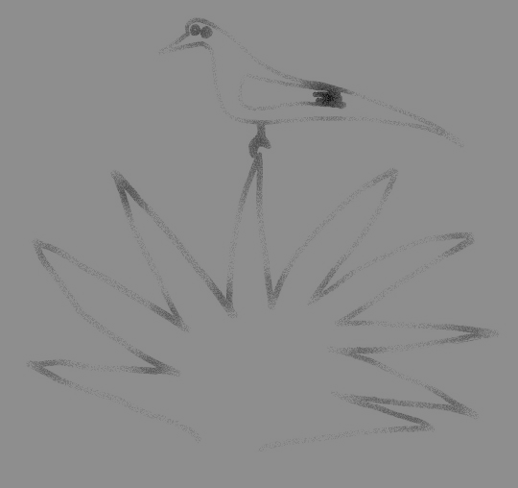
Family History Writing Specialists
Writing, Editing, Compiling, Consulting
Dr Fred Pinnegar PhD
612 West 1550 North; Orem, Utah 84057
801-368-6005
FamilyHistoryWritingSpecialists.com

